
Photonics Means®…I want a table top in 2026
Hi,
this is our second year. We tried to make this as slick, easy and simple as possible.
We aim for one form, including instructions. Wish us luck!
For 2026, we have a new level of simplicity. If you want the same as last year, just tick the first box on the form, then complete the signature box, name, date.
Simon.
Health and Safety Declaration
By signing this form you confirm that you will be fulfilling all of these options:
- If I have a laptop, or other purchased electrical device, it will be PAT tested within two years of bringing it.
  - I will visually check the cable and if it is faulty I will not use it.
- If I bring any other hazardous goods or materials, such as lasers, LEDs, mechanical moving parts, radioactive sources, liquids, gasses, or biohazard, I will have completed my own full Risk Assessment and will bring it with me on paper to show the organiser at their request.
- I have Public Liability Insurance of at least £1M coverage and can prove it if asked by supplying current certificate.
- The organisers, Fraunhofer UK, and the building owner, University of Strathclyde, reserve the absolute right to tell you to switch off equipment, at our sole discretion.
You will be supplied with:
- One table, approx 6 ft by 2ft
- One standard tablecloth. You are also free to bring your own.
- Space behind your table for two pull-up/banner stands.
- Two chairs
- Access to UK mains electricity. One socket. If you need more, let us know.
- Coffee and lunch are free for all attendees and exhibitors
- ‘Beach Party’- we are planning on beer, fish n chips and fun.
- Possible, to be confirmed: job adverts in ‘Careers Corner’
- Possible, do a talk in the auditorium, in the ‘New Technology ‘ session solely for exhibitors. . We will be selecting those who offer some novelty, innovation, new application type talks.

Venue
Level 2 and Level 3, TIC, 99 George Street, Glasgow G1 1RD.
(Level 2 is street level)
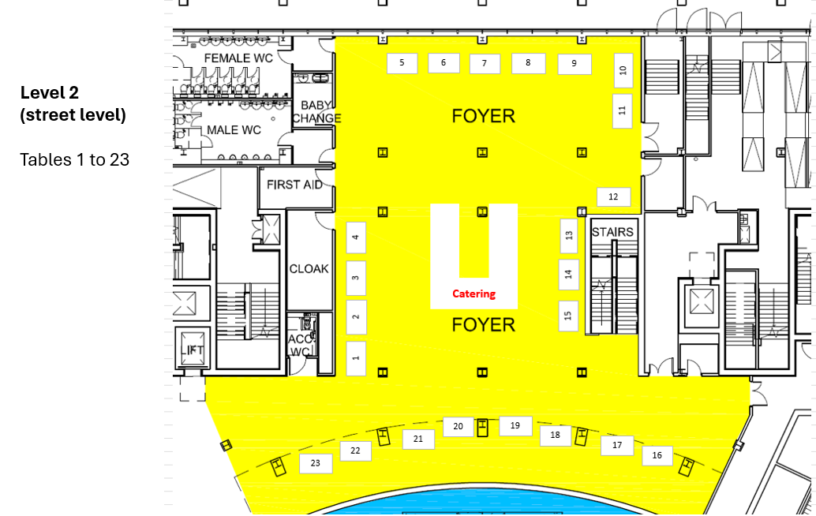
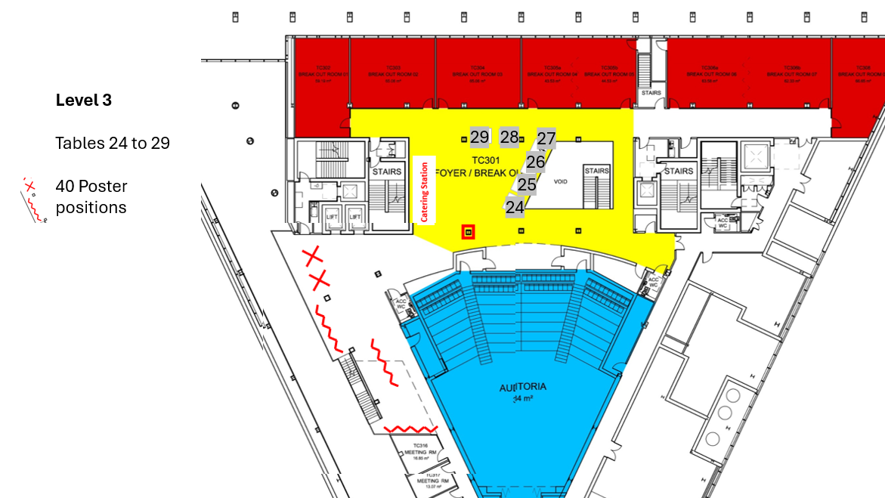

Timing
Wednesday 30th September 2026
8am | Earliest courier deliveries to Shuttle Street.
There is another exhibition on until 6pm, breaking down until 8.30pm.

8.30pm -10pm | Optional exhibitor Set-Up | The buffet was hardly used last year, so will not be provided this year.
10pm | Building closes
Thursday 1st October 2026
7am-8am | Exhibitor set-up
8am Exhibit open 8 til 4pm
 |  | Coffee Tea Level 2 and Level 3
 | 10.30-12 | Some talks in the Auditoria
 | 12- 1.30 | Lunch is served on Level 2 and Level 3, i.e. in the exhibition spaces
 | 1.30-3 | Some talks in the Auditoria
 | 3-4
4pm You may pack-up after 4pm. | 4 – 6pm | ‘Beach Party’ 4 to 6
5pm |  | Mini fish and chips and ice cream served
5.30 |  | Any prizes etc
6pm |  | All close

Deliveries
If you are hand carrying, please enter through the front door, 99 George Street.
If you have things arriving by courier, the address is
TIC, Shuttle Street, Glasgow G1 1RD.
The events team in the building have an event running in the days before our event. So please do not have deliveries arrive more than 24 hours before the start of our event.
2026: please do not have delivery arrive before 8am Wednesday 30th September
Pickup
Please arrange pick up for asap after the event.
NB the building is closed on Saturdays and Sunday, pick up is not possible at all on weekends.
You will need to have everything packed, labelled, arranged with you own preferred shipment company.
The TIC venue staff - ask for ‘Stores’, led by Peter Costello, will be pleased to help you.
They will come around in the afternoon to get information from you.
Travel and accommodation
Finding our building
Photonics Means… will be located in the 'TIC' building,
Technology and Innovation Centre on the University of Strathclyde's Glasgow City Centre campus.
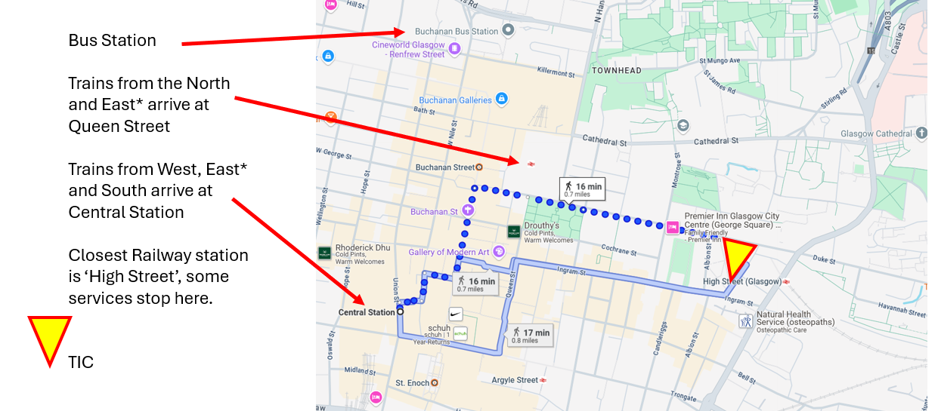
Nearby Hotels
Moxy Glasgow Merchant City
210 High Street, Glasgow, G4 0QW United Kingdom
+441418460256
Z Hotel
36 North Frederick Street
Glasgow
G1 2BS
+44 (0) 141 212 4550
Premier Inn Glasgow City Centre (George Square)
187 George Street
Glasgow G1 1YU
Tel: 0871 527 8440
Millenium Hotel Glasgow
George Square
Glasgow G2 1DS
Tel: 0141 332 6711
AC Hotel (Marriott)
260 George St, Glasgow G1 1QX
01417260340
Carlton George Hotel
44 West George Street
Glasgow G2 1DH
(0)141 353 6373

By air
A number of airlines have UK and EU flights arriving at Glasgow International Airport (GLA) www.glasgowairport.com
(N.B A taxi from the Glasgow International Airport, GLA, to the University costs around £35. Glasgow city taxis 0141 429 7070)Please note that the so-called ‘Glasgow Prestwick’ Airport, PIK, is 32 miles / 52km from Glasgow. It is close to the town of Prestwick. But has a direct rail link to Glasgow Central station.
Local travel
Buses run between Glasgow International Airport and Buchanan Street bus station, 500 service.( 15 minutes walk away) at regular intervals throughout the day.
The nearest car park is the NCP on Montrose Street, (£12 per day) other car parks are accessed via Collins Street (around £5 per day, change required, or pay by mobile phone)
Trains
Glasgow Queen Street railway station is a 5 minute walk away.
Glasgow Central railway station is a 20 minute walk away.
Glasgow has a simple circular underground system which is convenient for commuting between the City Centre and the west end. Eg Buchanan Street(city centre) stop to Hillhead stop (west end and the University of Glasgow)
Car Parking nearby
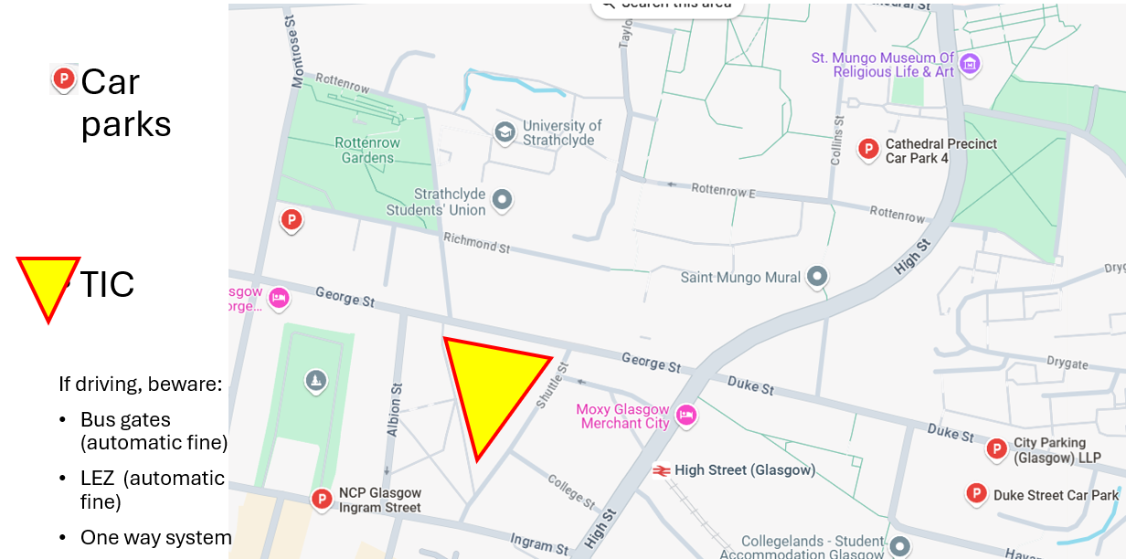

Packing up your tabletop, no pack-up before 4pm.
We know it is a 20 minute walk to Glasgow Central Station, we know it is a Friday. Sorry.
(2025 edition Friday 10th October, but future years will never be Fridays)
But please make travel plans based on NOT breaking down until 4.00pm.
Anyway, there will be a lively party from 4 to 6 with beer and some nice food, so please plan to join in the party.

What happens next, 3 things for you to do, three boxes to tick:
- Email the signed completed form to photonics@fraunhofer.co.uk
  - Feel free to delete the rest of the document and just send the form.
- Email us your company logo, IF IT HAS CHANGED FROM LAST YEAR, implying we may put it on publicity about the event, to photonics@fraunhofer.co.uk
- You need to register all exhibitors and/or attendees please, including the person filling in this form.
  - We will not have separate exhibitor badges. The registration is here:
  - Photonics Means... Tickets, Fri, Oct 10, 2025 at 8:00 AM | Eventbrite

Later:
- We will have an online Teams call for all your burning questions at 8am 1 September 2026 online.
- We will see you here on Thursday 1st October 2026
- We will send you an invoice around 10th October.
- We will expect this paid within thirty days. Thanks.

If you want to set up payment / Purchase Order to us you may need to know
Fraunhofer UK Research Ltd , SC419797, 99 George Street, Glasgow G1 1RD
VAT number GB131646530
Our finance contact: Sarah.Jowett@Fraunhofer.co.uk 0141 548 4665

Photonics Means®… will return
date for your diary, for the following year’s event…
Thursday 1 October 2026

Photonics Means®… 2026 JUST ONE FORM TO SEND BACK | Answer:
If you exhibited last year you may tick this box to say ‘all the same as last year’. Skip all the other questions and complete the signature section. | Everything the same as last year? Y / N / NA
Organisation/company/project name you wish to appear on the website/programme/publicity
Legal entity to put on the invoice, whoever is paying the bill:
My preferred table location (you can give a few numbers in order of preference if you like, we will try to accommodate best we can)
Additional sockets (you have 1 already. So if you answer 3 you will get 4.)

Additional chairs required (you have 2 already. So if you answer 3 you will get 5)

I want a big TV/display on a stand for £150 plus VAT (yes/no) 1 max per table.

I also need to tell you that…

I have a question…

Email address(es) for correspondence about this event.

Email address to send the invoice to
Anything else you want written on your invoice?
I would like to do a talk (please not pure sales pitch. Please have some content about field trials or novel applications or something innovative (yes/no)
By signing this form, you are telling us you are an authorised signatory for your company and that you confirm all these details above and also:
- I hereby confirm that we will comply with the H and S Declaration on this document.
- I hereby confirm that if we start to breakdown our display before 4pm, we know we will never be invited back.
- I will now register for the event, and get any other colleagues exhibiting to also register.
- I will receive an invoice for £700 plus VAT. (and £150 plus VAT if I order a TV)
Signed

Name
Position/ Job title of the signatory
Date
Now send this form, and any new logos, to photonics@fraunhofer.co.uk
Register. You and all your attending staff need to register, https://www.eventbrite.co.uk/o/photonics-means-delivered-by-fraunhofer-uk-3294980532

